**Final Report**

**Expert System**

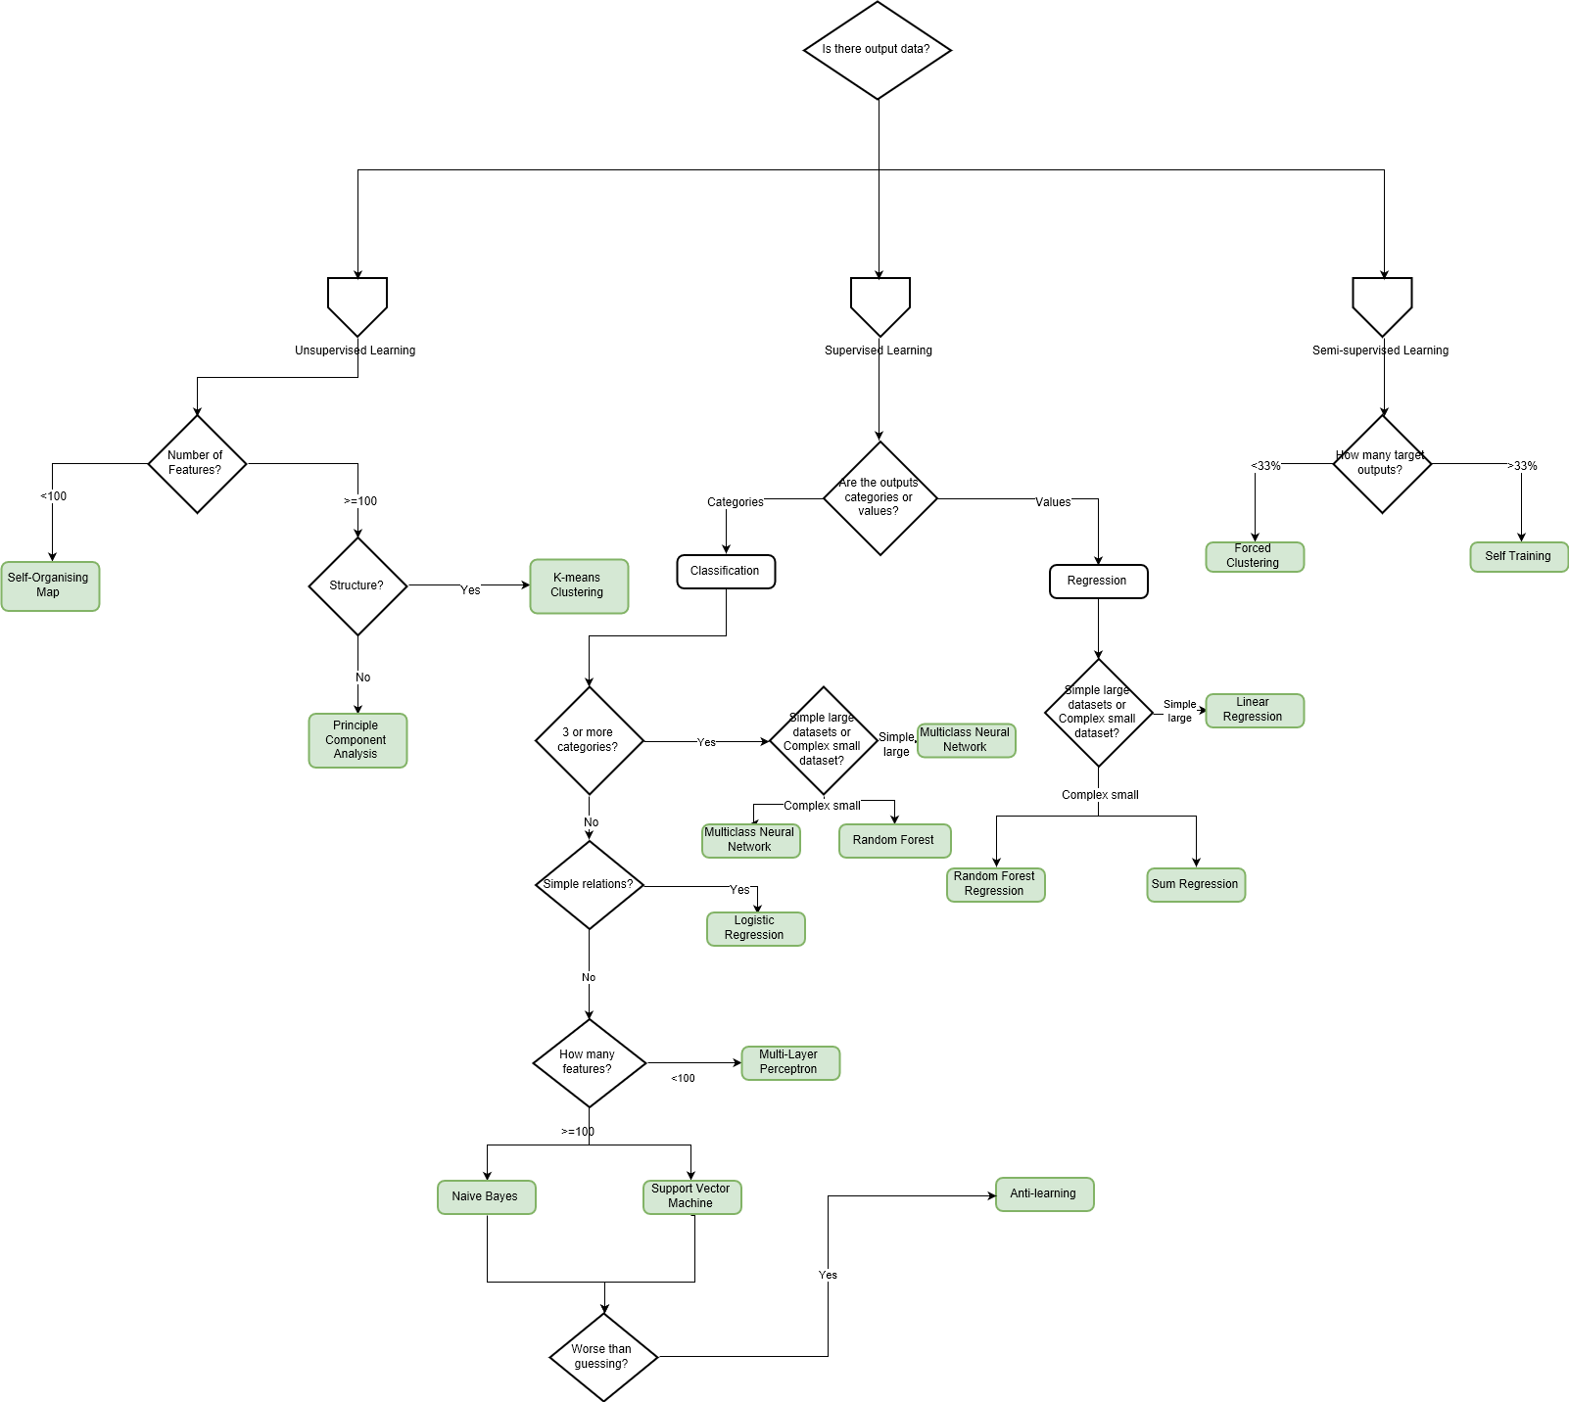In order to intelligently select the appropriate machine learning method based on the dataset provided by the user, the team consulted Dr Chris Roadknight, a senior expert in machine learning, to obtain relevant implementation methods. Through constant inquiries and conclusions, with the help and advice of Dr Roadknight, the team made a decision tree as an expert system to meet the demand.

By using the following attributes obtained from database as inputs to through the decision tree:

name,

headings,

number-of-features,

values,

missing-values,

${original-values}^{2}$,

anomalies,

labels,

missing-labels,

data-type,

size,

labels-ratio,

is-categorical,

${categories}^{3}$,

complexity,

structure,

relations

After reached the end of the tree, a machine learning method will be given and suggest user to use specific method.

For instance, after a user upload a dataset, pre-processing step will give a set of these attributes as following:

1. anomalies: (2) [{…}, {…}]
2. categories: null
3. complexity: 78.85022290809326
4. dataType: "number"
5. headings: (4) ["ColA", "ColB", "ColC", "ColD"]
6. imputedVals: (9) [Array(4), Array(4), Array(4), Array(4), Array(4), Array(4), Array(4), Array(4), Array(4)]
7. isCategorical: false
8. labels: (9) ["1", "2", "3", "4", "5", "6", "7", "8", "9"]
9. labelsRatio: 1
10. missingLabels: []
11. missingValues: (4) [{…}, {…}, {…}, {…}]
12. name: "testing.csv"
13. numFeatures: 4
14. originalVals: (9) [Array(4), Array(4), Array(4), Array(4), Array(4), Array(4), Array(4), Array(4), Array(4)]
15. relations: null
16. size: 9
17. structure: -0.015007523470171
18. vals: (9) [Array(4), Array(4), Array(4), Array(4), Array(4), Array(4), Array(4), Array(4), Array(4)]
19. __v: 0
20. _id: "5c0680f3b3126344c8e153ea"

These attributes will go through the entire decision tree which implemented by JavaScript. After judgement of ‘if’ statement, program will give a final result:

“Recommend use Sum Regression or Random Forest Regression”